**Dashboard for the SuperMarket**ReportView  
  
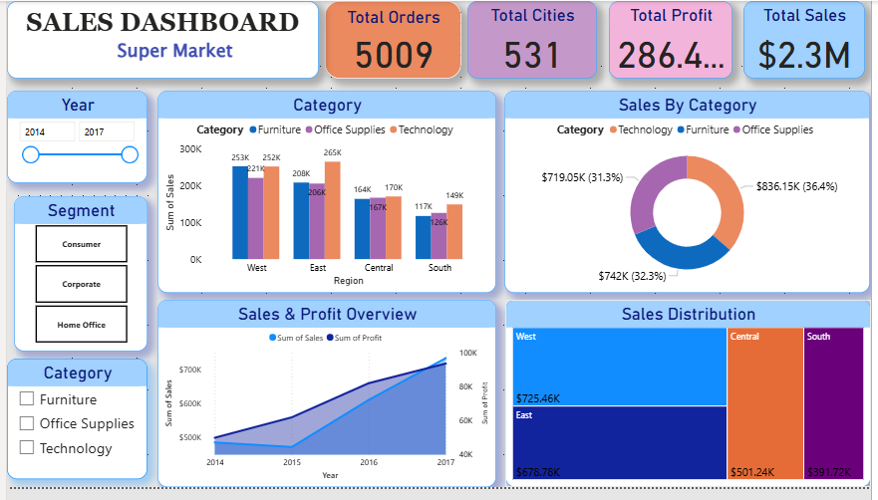

* Create a Single card
  + Total Sales
  + Total Profit
  + Total Orders
  + Total cities Covers
* Create a Slicers year wise (we have a data of 2014 -2017) (Display type -Between)

(we can check the report year wise)

* + 2014
  + 2015
  + 2016
  + 2017
* Create a Slicer Segment wise (display Type->Tilewise)
  + Consumer
  + Corporate
  + Home Office
* Create a Slicer Category(Display Type->Vertical List)
  + Furniture
  + Technology
  + Office Supplies
* Added in the Clustered Column Chart for sales in Category and the region wise (East, West, North South)
  + Furniture
  + Technology
  + Office Supplies
* Added the sales for the Category in the Donut Chart
* (Added profit and the Quantity in the tooltip)
  + Furniture
  + Technology
  + Office Supplies
* Added the sales and the Profit for the year wise int the Area Chart
* Add the sales and the location hierarchy in the Tree Map
* (Also apply a drill through feature in it)
* Data View  
    
  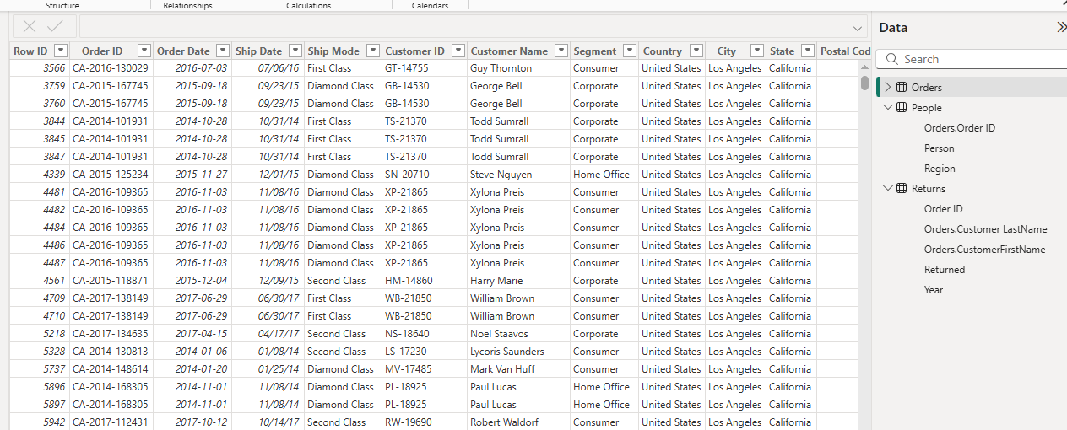  
    
  Model View  
    
  